Welcome!
Date
Name
Spouse
Address
City
State Zip _________
Email

Please Contact By
❑ Card  Phone  Visit

Telephone Best Time to Call
Home ______________
Work ______________

Guest: First Time Second Time
Are you a church member: yes no
Church
City, State

Circle Appropriate Age/Grade Group(s)
Preschool: Ages: B-1 2-3 4-5
Children: Grades: K 1 2 3 4 5 6
Youth: Grades: 7 8 9 10 11 12
Adults: Ages:18-29 30s 40s 50s 60s+

How did you learn about our church?
Newspaper Friend Yellow Pages Mail
Other

I am a guest of:

New in the Community? Yes No
Names & ages of children at home

Weekly Service & Activity Schedule

November 29, 2015

9:45 a.m. Sunday School
11:00 a.m. Worship Service
There will not be an evening worship service

Week of November 29, 2015

Wednesday 6:30 pm………..Meal/Adult Bible Study

Upcoming Events

December
Nov 29 – Dec 5…..Week of Prayer – Lottie Moon Missions
13……………..……………..Children’s Christmas Program
20…………………………………………….Business Meeting
25………………………………………………..Christmas Day
31……………….…………..….New Year’s Eve Watch Party
January
1…………………………………….………….New Year’s Day
Children’s Christmas Program practice will be held every Sunday morning @ 9:15. If your child plans on participating in the program, please plan on being there.

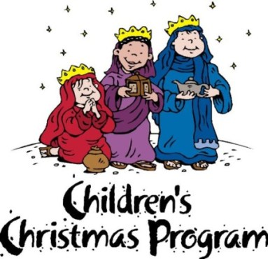

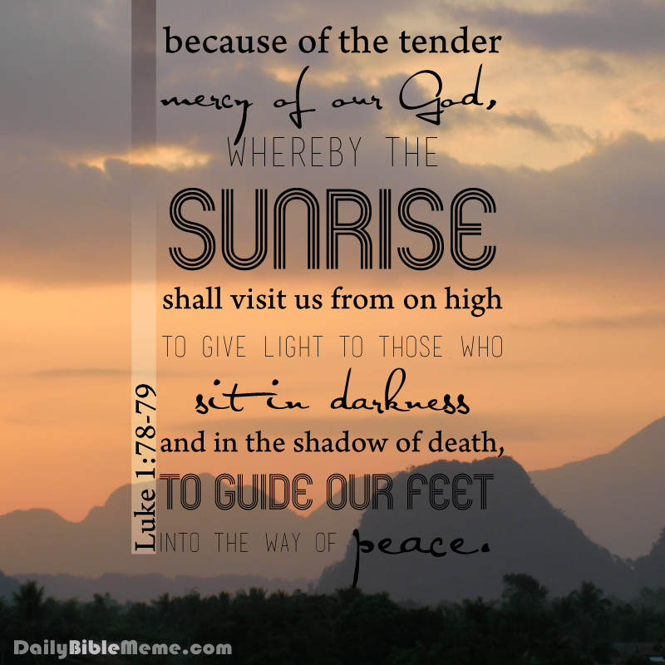

Knobbs Springs Baptist Church

November 29, 2015

Church Information:

KnobbsSpringsBC.com KnobbsSpringsBaptist@gmail.com

1662 CR 305, McDade, Texas 78650 512-273-2743

David Atwood, Pastor Cell 512-470-5098
Home 512-856-2819
Patti Radford, Office Manager Cell 512-968-7821

